

**FlyAway (An Airline Booking Portal)**

07.09.2020

**─**

SONAM

COMPANY NAME: **FlyAway**

This code is d eveloped by : - **SONAM**

The code for this project i s hosted at:

# Overview

As a Full Stack Developer, designing and developing an airline booking portal named as

FlyAway. Use the GitHub repository to manage the project artifacts.

# Goals

1. FlyAway is a ticket-booking portal that lets people book flights on their website.
2. A search form in the homepage to allow entry of travel details, like the date of travel, source, destination, and the number of persons
3. Based on the travel details entered, it will show the available flights with their ticket prices.
4. Once a person selects a flight to book, they will be taken to a register page where they must fill in their personal details. In the next page, they are shown the flight details of the flight that they are booking, and the payment is done via a dummy payment gateway. On completion of the payment, they are shown a confirmation page with the details of the booking.
5. there will be an admin backend with the following features:
6. An admin login page where the admin can change the password after login, if he wishes
7. A master list of places for source and destination
8. A master list of airlines
9. A list of flights where each flight has a source, destination, airline, and ticket price

# Specifications

* Eclipse/IntelliJ: An IDE to code for the application
* Java: A programming language to develop the web pages, databases, and others
* SQL: To create tables for admin, airlines, and other specifics
* Maven: To create a web-enabled Maven project
* Git: To connect and push files from the local system to GitHub
* GitHub: To store the application code and track its versions
* Scrum: An efficient agile framework to deliver the product incrementally
* Search and Sort techniques: Data structures used for the project
* Specification document: Any open-source document or Google Docs

Sprints planned and the tasks achieved in t hem

Flyaway was divided in 3 sprints of 1 week each.

**Sprint 1** : ‐

Initialized the project, made it Hibernate project and added dependencies

MySql connector, Hibernate libraries, Servlet API. S etting MySQL database environment and tomcat server Made E.R. diagram for database a nd entities relationship.

Made classes for entities and established relationships between t hem. Configured hibernate and mapped classes a s entities. Populated the data by h ibernate

**Sprint 2** : ‐

Planned the structure o f the w ebsite and navigation across it. M ade a Hibernate u til. class to use it across t he servlets.

Made servlets for each class list and set up navigation links for t hem. M ade a c ommon View page for each class’s view rendering.

Made the header and footer jsp pages t o i nclude it across every page. M ade an e rror p age errorpage.jsp and set it as the error page for the whole website by including it in the header tag of header.jsp file.

**Sprint 3** : ‐

Made the master list JSP for master list of places for source a nd destination, master list o f airlines. A lso Made A list of flights w here each flight has a source, destination, airline, a nd ticket price Set up Servlets for each of t he master list to s end data as a l ist.

# Flow chart

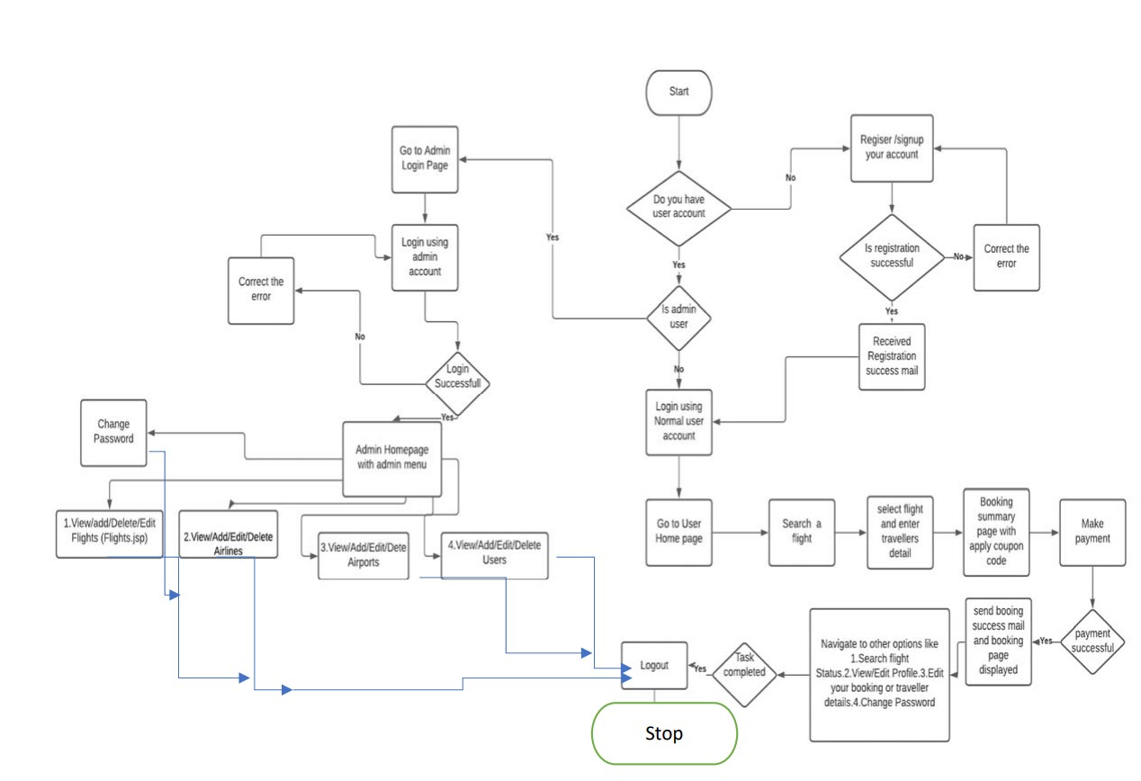

# Front html (view):-

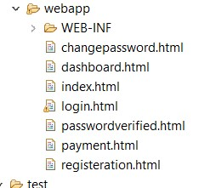

# Servlets(Controller) : ‐

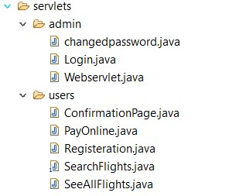

# Hibernate:-

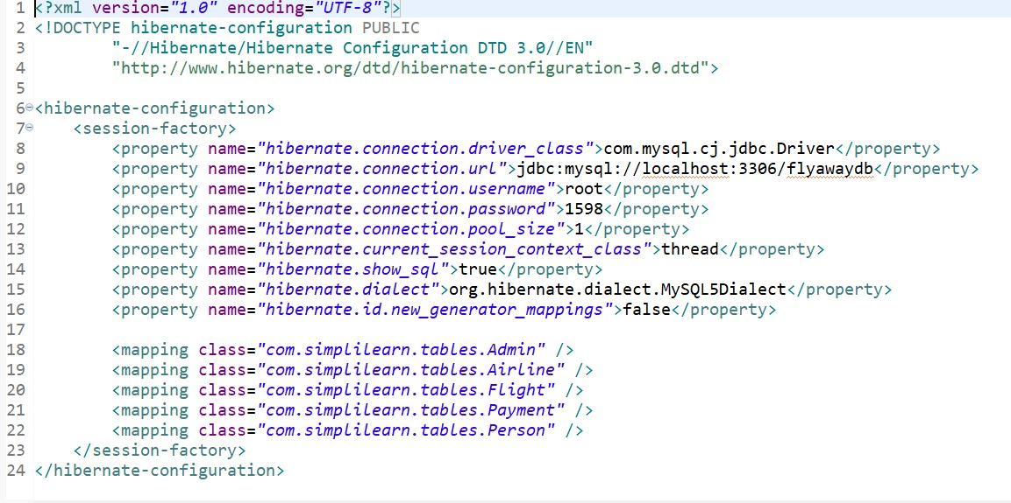

# Tools used

**Apache Tomcat server 9.0.52 Mysql 8.0.26 Java 1.8 Maven dependency**

# output

## Admin Page of F lyaway project

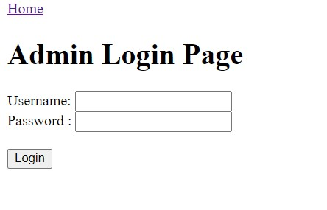

## Search for F ights

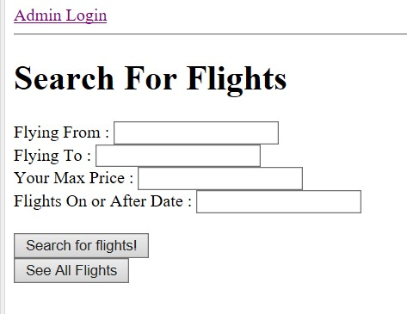

## View the Master List of Airlines

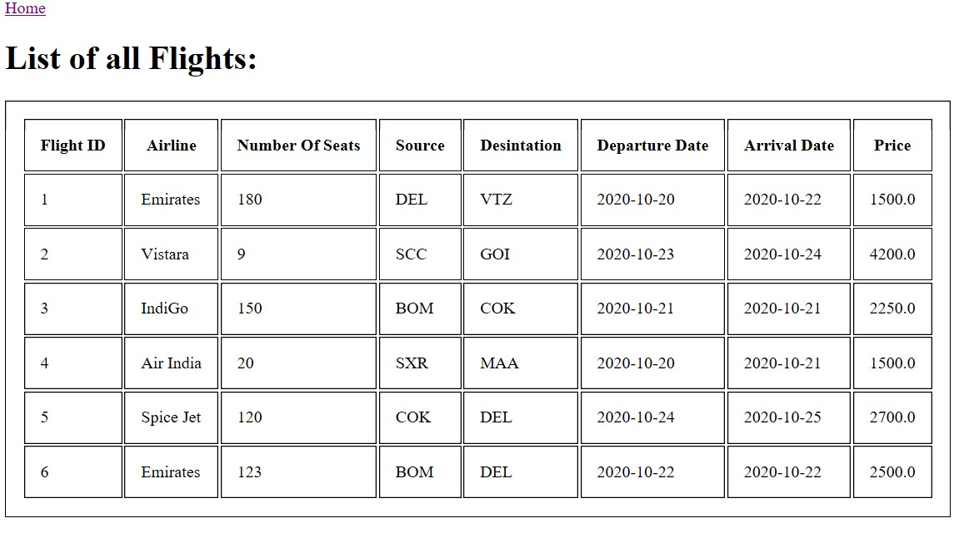

## Flight Registration Page

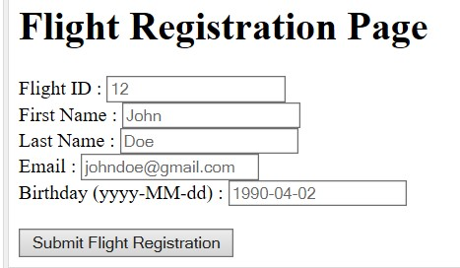

## Conformation R egistration page

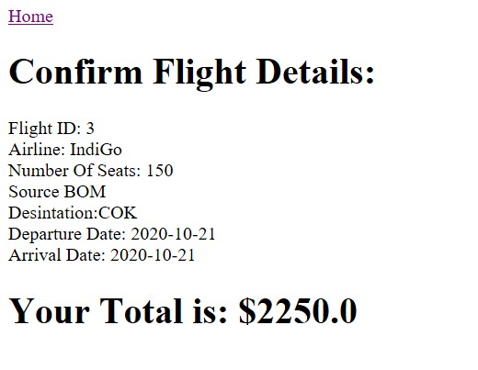 **Payment Details After Confirmation**

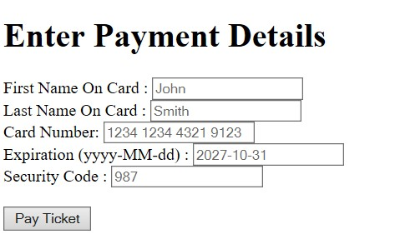

## Registration confirmation page

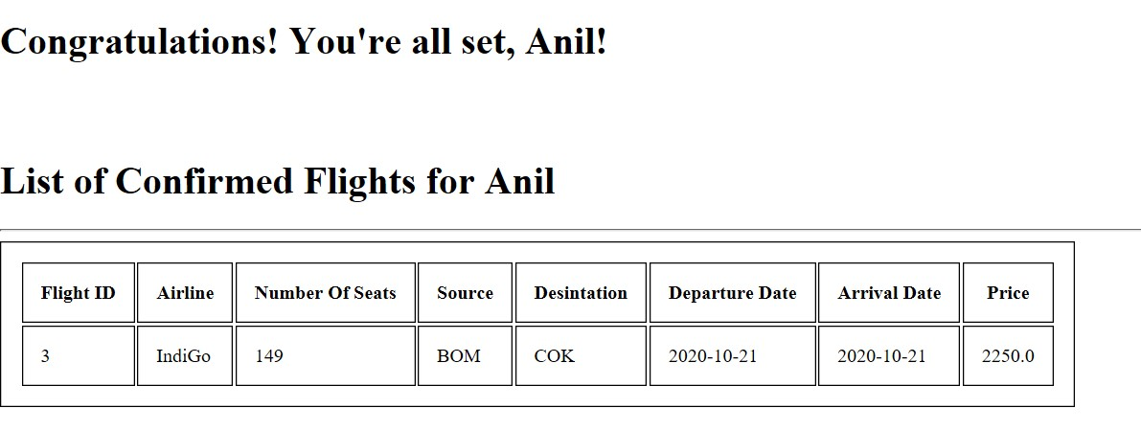 **Conclusion**

The purpose of this Application was to identify effective strategies for dealing with flight booking applications by making the process of the application to benefit the users. It conserves resources and time and is one of those which helps users to ease the process and have best and easy flight booking. Providing users, the options to retrieve flights, options of flights of their choice into their bookings, more options like payment details and booking confirmation details. This Application also manages the exception and error for users to guide them in a better way and give the best solution while working. Future exploration into behavior modification techniques could be useful to finding further techniques to work with the payment module.